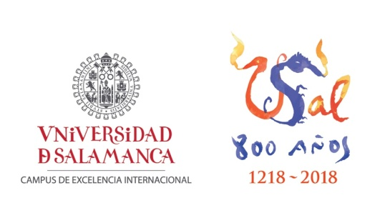

RESERVATION REQUEST FOR CONGRESS ACCOMODATION
11th International Conference on Chicano Literature and Latino Studies
May 28-30 2018

PERSONAL INFORMATION
Last Name(s):………………………………….………………………………………..….. First Name:……..……………..………...………...
DNI:…………………….……… Address:……………………………….……………………………………………………………………………...
CP:………...…… City:…………………….………..……..……………………….Province:………………………………………………
Mobile:……………..…………Email:……………………………………………………………………………..
Complete information for the invoice (Entity/Company/Individual, home, population CP and NIF/CIF)
If the information is the same as those indicated above, it is not necessary to put them below:
……………………………………………………………………………………………………………………………………………………………………………………………………………………………………………………………………………………………………………………………………………...
LODGING RESERVATION
NAME OF HOTEL: | DUI * | DOUBLE |  |  |  | RERSERVATION DEADLINE
CATALONIA PLAZA MAYOR | 92€ | 108€ |  |  |  | 20/03/2018
NH PUERTA DE LA CATEDRAL | 112€ | 123€ |  |  |  | 20/03/2018
SILKEN RONA DALBA | 65,50€ | 75€ |  |  |  | 20/03/2018
SOHO BOUTIQUE | 70€ | 80€ |  |  |  | 20/03/2018
SOHO MERCADO CENTRAL | 55€ | 65€ |  |  |  | 20/03/2018
*DUI: Double room for single use
Prices per night, bed and breakfast. IVA included.
Arrival date at Hotel: ….../…... Departure date of Hotel: ….../…... Number of nights: ………...
Number of rooms: …………. Hotel chosen: …………….………..…………………….………. Room type: ………..………… Total Number of people: …….…………… Total amount reserved: …………………………………(Euros)
(If you need to reserve for the night of May 27, please indicate it in the petition).

PAYMENT METHODS
□ Bank transfer
In favor of Halcón Viajes Cta. Nº ES52 0081 5172 860001177422 BANCO SABADELL, indicate as “Name and last name- Hotel reserved”
□ Credit card
I authorize to charge the amount indicated above, “total amount” on my Visa/Mastercard/4B credit card.
Cardholder:
Card Number : Exp:
………………, a….de………. de 2.018 Signature of
cardholder:

To formalize the accommodation reservation, you must send this request properly completed via email to usal@halconviajes.com indicating the name of the congress and the participant.
Once the request email is received, we will confirm by the same reservation. If you chose a bank transfer as a payment method, it is necessary to send a mail copy of it.
If you have any questions or problems please contact Ángeles Santos in the mail above or by phone: 923 21 02 81.

